Software Requirements Specification
for
LICENSE PLATE RECOGNITION
Version 1.0

Prepared by
Group Name: 13
Arinda Johnson | 22/U/5032/EVE | arindaj33@gmail.com
Zirimabagabo Anslem | 22/U/7076 | zbagagabo@gmail.com
Mukisa Don Joseph | 22/U/6365 | donmukisajoseph@gmail.com

Mentor: | Mr Asiimwe Paddy
Course: | CSC 1304 Practical Skills Development
Date: | 20-08-2023
Contents
Revisions iii
1 Introduction 1
1.1 Document Purpose 1
1.2 Product Scope 1
1.3 Intended Audience and Document Overview 1
1.4 Definitions, Acronyms and Abbreviations 1
1.5 Document Conventions 1
1.6 References and Acknowledgments 2
2 Overall Description 3
2.1 Product Perspective 3
2.2 Product Functionality 3
2.3 Users and Characteristics 3
2.4 Operating Environment 3
2.5 Design and Implementation Constraints 4
2.6 User Documentation 4
2.7 Assumptions and Dependencies 4
3 Specific Requirements 5
3.1 External Interface Requirements 5
3.2 Functional Requirements 6
3.3 Behaviour Requirements 6
4 Other Non-functional Requirements 7
4.1 Performance Requirements 7
4.2 Safety and Security Requirements 7
4.3 Software Quality Attributes 7
5 Other Requirements 8
Appendix B - Group Log 9

Revisions
Version | Primary Author(s) | Description of Version | Date Completed
1 | Mukisa Don Joseph  Arinda Johnson  Zirimabagabo Anslem | This is the initial version of report for the Automatic Number plate Recognition System | 20/08/2023

Introduction

Document Purpose
This document outlines the software requirements for the embedded system designed to capture images and videos, detect license plates within these media, and ascertain the last known location of the vehicle in question. It serves as a comprehensive guide for the development and implementation of this system, specifying the functional and non-functional requirements necessary to achieve its objectives. This document's primary purpose is to provide a clear and detailed understanding of the system's requirements to guide the development team and other stakeholders.

Product Scope
The software specified in this document aims to create an embedded system capable of capturing images and videos, processing them to detect license plates, and subsequently determining the last known location of the vehicles associated with these plates. The system's primary purpose is to enhance security, traffic management, and surveillance applications. It will benefit various sectors, including law enforcement, parking management, and vehicle tracking. The key objectives of this product are to improve accuracy in license plate recognition, ensure real-time processing, and offer a user-friendly interface for configuration and monitoring.

Intended Audience and Document Overview
Intended Audiences:
- Developers: To understand the technical requirements and specifications for system implementation.
- Project Managers: To gain insights into project scope, objectives, and resource allocation.
- Marketing Staff: To understand the product's potential benefits and features.
- Users: To comprehend the system's capabilities and functionality.
- Testers: To derive test cases and scenarios for system validation.
- Documentation Writers: To create user manuals and system documentation.
- Client: To review and approve the system's requirements.
Document Overview:
- Section 1 (Introduction): Provides an overview of the document's purpose, the scope of the product, intended audience, document conventions, definitions, acronyms, abbreviations, references, and acknowledgments.
- Section 2 (Functional Requirements): Details the system's functional specifications, including use cases, requirements, and interactions.
- Section 3 (Non-Functional Requirements): Describes the system's non-functional specifications, such as performance, security, and reliability requirements.
- Section 4 (System Design): Offers an outline of the system architecture, data flow, and interface specifications.
- Section 5 (Testing Requirements): Defines the testing strategies, test cases, and validation procedures.
- Section 6 (User Interface): Presents the user interface design and user interaction specifications.
- Section 7 (Maintenance and Support): Outlines the requirements for system maintenance, updates, and support.
- Section 8 (Appendices): Contains additional information, including diagrams, charts, and supplementary details.

Definitions, Acronyms and Abbreviations
- SRS: Software Requirements Specification
- IEEE: Institute of Electrical and Electronics Engineers

Document Conventions
This document follows the IEEE formatting requirements, utilizing Arial font size 11 for text. Section and subsection titles are formatted as specified in the template. Text is single-spaced, maintaining 1" margins. Comments are presented in italics.

References and Acknowledgments
References and acknowledgments related to this SRS will be included in a dedicated section within the document, adhering to IEEE citation standards.

Overall Description

Product Perspective
The license plate recognition embedded system is designed as a standalone product, focused on capturing images and videos, detecting license plates within them, and determining the last known location of the associated vehicles. While it functions independently, it can also serve as a subsystem within larger surveillance, security, or traffic management systems.

System Context diagram:

Product Functionality
The major functions of the license plate recognition embedded system include:
- Image and Video Capture: The system can capture images and videos from connected cameras or video sources.
- License Plate Detection: It detects license plates within the captured images or video frames.
- Character Recognition: Utilizes Optical Character Recognition (OCR) to extract and identify characters from detected license plates.
- Last Known Location: Determines and records the last known location of vehicles associated with the recognized license plates.
- User Interface: Provides a user-friendly interface for system configuration, monitoring, and data retrieval.
- Database Integration: Optionally, recognition results can be stored in a database for auditing and analysis purposes.

Users and Characteristics
The anticipated users of this system include:
- Security Personnel: These users, often in law enforcement or private security roles, will utilize the system to monitor and track vehicles of interest.
- Traffic Management Authorities: Traffic management professionals can use the system to enhance traffic control and monitor vehicle movements.
- Parking Management Operators: Operators responsible for parking facilities can employ the system to manage access and billing based on license plate recognition.
Users may have varying levels of technical expertise, but the system is designed to be user-friendly and intuitive. Security personnel, for example, may require real-time monitoring capabilities, while traffic management authorities might focus on historical data analysis.

Operating Environment
The system will operate in the following environment:
Hardware Platform: The system is designed to run on embedded computing hardware capable of image and video processing. Minimum platform requirements will include a dual-core processor, a GPU for accelerated processing, and sufficient memory for image buffers.
- Operating System: The software will run on a Linux-based operating system, optimized for embedded applications.
- Software Components: The system will rely on OpenCV for image processing, Tesseract for OCR, and a relational database (e.g., PostgreSQL) for data storage.
- External Interfaces: The system will interface with cameras or video sources through standard communication protocols (e.g., RTSP, HTTP).

Design and Implementation Constraints
The following constraints impact the design and implementation of the system:
- Hardware Limitations: The system's performance is dependent on the processing power and memory of the embedded hardware.
- Software Dependencies: It relies on external libraries such as OpenCV and Tesseract for image processing and OCR, which must be correctly configured and integrated.
- Real-time Processing: Real-time processing requirements impose constraints on response times and computational efficiency.
- Camera Compatibility: The system may need to be adapted to work with different camera models and configurations.
- Data Privacy Regulations: Compliance with data privacy regulations and ethical considerations is essential when handling license plate and location data.

User Documentation
User documentation for the system will include the following components:
- User Manual: A comprehensive manual explaining system installation, configuration, and usage.
- Administrator Guide: Documentation for system administrators, covering setup, maintenance, and troubleshooting.
- Online Help: Context-sensitive online help accessible within the user interface.
These documentation components will be provided in electronic formats, such as PDFs and online help, to facilitate ease of use and accessibility.

Assumptions and Dependencies:
Key assumptions and dependencies for the project include:
- Availability of Hardware: It is assumed that the required embedded hardware for system deployment will be available and compatible with the software.
- Software Dependencies: Dependencies on third-party software libraries, such as OpenCV and Tesseract, are assumed to be met with proper configuration.
- Data Sources: The system relies on camera feeds or video sources to capture images and videos. Assumptions include the availability and compatibility of these sources.
- Data Privacy Compliance: It is assumed that the system will be used in compliance with local data privacy regulations and ethical standards.
- Internet Connectivity: For certain features (e.g., remote monitoring), it is assumed that the system will have internet connectivity, if required by the deployment scenario.

Specific Requirements

External Interface Requirements

User Interfaces
The license plate recognition embedded system will feature the following user interfaces:

- Search and Reporting Interface: This interface enables users to search for historical data based on license plates, date, time, or location. Users can generate reports and export data for further analysis.
- Alerts and Notifications: The system will provide a mechanism for users to set up alerts and notifications for specific events, such as license plate matches or system errors.

Hardware Interfaces

Ov7675 camera,Arduino nano ble sense,tiny machine learning shield
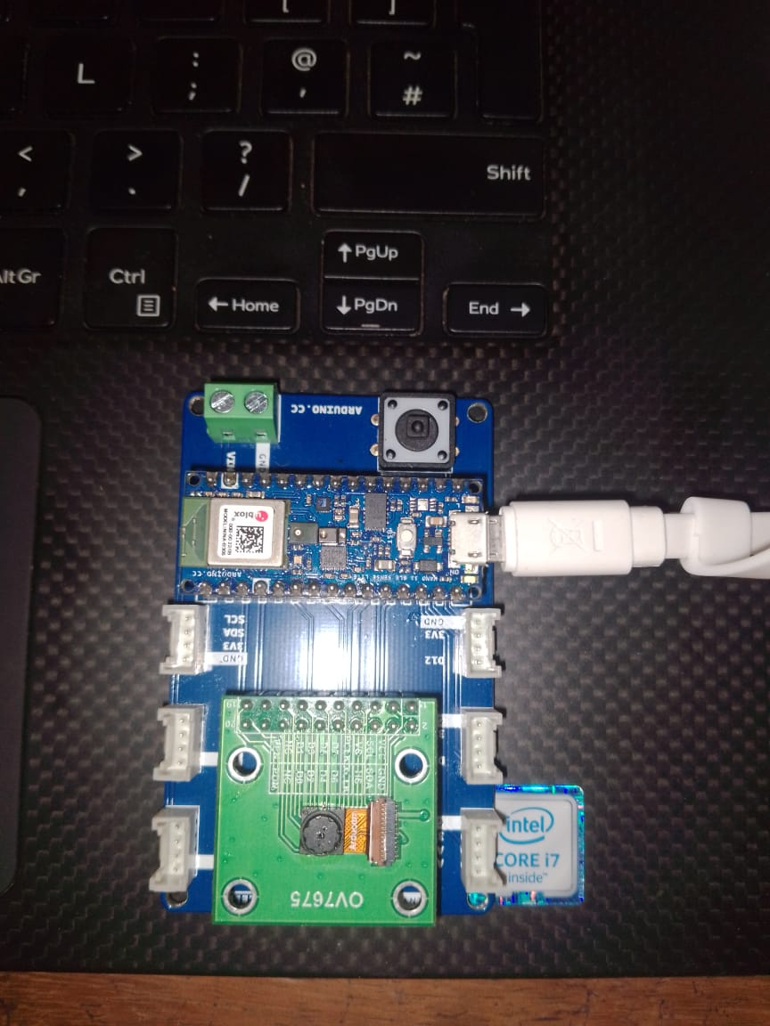

Software Interfaces
The primary software interface for the license plate recognition system is with the operating system. The system is designed to operate on any operating systems, and it may utilize specific libraries and components for image processing, OCR, and database interaction. Specific software interfaces include:
- OpenCV: The system will make use of the OpenCV library for image and video processing tasks, including image capture and manipulation.
- Google Vision APIs: To perform Optical Character Recognition (OCR) on detected license plates, the system will interface with the Google cloud vision based APIs.
- Database: For data storage and retrieval, the system may interface with relational databases such as Django, PostgreSQL or SQLite. It will use standard database communication protocols.

Communications Interfaces
Communication interfaces are essential for real-time monitoring, remote configuration, and data retrieval. The system will employ the following communication standards and methods:
- Network Protocols: The system will use standard network protocols such as HTTP and RTSP to communicate with external cameras and remote monitoring interfaces.

Functional Requirements
3.2.1 Image Capture and Processing

3.2.1.1 Image Capture
The system shall be able to capture license plate images from various sources, including cameras installed at entry and exit points. These images shall be stored in a designated location for further processing.

3.2.1.2 Image Preprocessing
Upon capture, the system shall apply preprocessing techniques to enhance image quality and readability. This may involve resizing, noise reduction, contrast adjustment, and rotation correction.

3.2.1.3 License Plate Detection
The system shall use computer vision algorithms to detect the presence of a license plate within the preprocessed image. Once detected, the system shall isolate and extract the license plate region for further analysis.

3.2.2 License Plate Recognition and Storage

3.2.2.1 Character Segmentation
For each extracted license plate region, the system shall segment individual characters on the license plate using segmentation techniques, ensuring accurate separation of characters for recognition.

3.2.2.2 Optical Character Recognition (OCR)
The system shall perform OCR on the segmented characters to recognize the alphanumeric characters on the license plate. The recognized characters shall be stored along with a timestamp and the associated image.

3.2.2.3 License Plate Database
The system shall maintain a database to store recognized license plate information, including the recognized characters, the corresponding image, the timestamp of the capture, and the location where the image was taken.

3.2.3 User Interface and Interaction

3.2.3.1 User Login and Authentication
The system shall provide a secure user authentication mechanism, requiring users to log in with valid credentials before accessing the system's functionalities.

3.2.3.2 License Plate Search
Authorized users shall be able to search for license plate records based on various criteria, such as recognized characters, capture date, and location. The search results shall be displayed in a user-friendly manner.

3.2.3.3 Image Viewing
Users shall have the ability to view the captured license plate images associated with each record. These images shall be displayed within the user interface along with relevant metadata.

3.2.4 System Administration and Maintenance

3.2.4.1 User Management
Administrators shall be able to manage user accounts, including creating, updating, and deleting accounts, as well as assigning different levels of access permissions.

3.2.4.2 Data Backup and Restore
The system shall provide functionality for administrators to perform regular backups of the license plate database and the associated images. Additionally, it shall support the restoration of data from backups if necessary.

3.2.4.3 System Monitoring and Alerts
The system shall have built-in monitoring capabilities to track its performance and health. Administrators shall receive alerts in case of critical issues, such as system failures or low storage space.

These functional requirements have been categorized into functional areas to clearly define the system's intended behavior. Each requirement specifies a specific operation or task that contributes to the overall functionality of the ANPR system..

Other Non-functional Requirements

Performance Requirements

The ANPR system shall process and analyze license plate images in real-time, with a maximum processing time of 2 seconds per image. This will ensure timely identification of vehicles entering or exiting monitored areas.

The system shall be capable of handling a minimum of 100 concurrent license plate recognition requests without experiencing degradation in performance. This will ensure smooth operation during periods of high traffic.

The average accuracy of license plate recognition shall be at least 95%, with a recognition rate of no less than 85% for license plates in challenging lighting conditions or non-standard orientations. This will ensure reliable identification across a variety of scenarios.

Safety and Security Requirements

Data Privacy :The system shall ensure the privacy of captured license plate images and associated data. Personal information of vehicle owners shall be protected in compliance with relevant data protection laws.

User Access Control:The system shall implement role-based access control, allowing administrators to define different levels of access for users. Users shall only be able to access functionalities and data relevant to their assigned roles.

4.2.3 Error Handling :In case of system errors or failures, the system shall provide clear and informative error messages to users and administrators. Critical errors shall trigger alerts to appropriate personnel for prompt resolution.

Security Requirements:The client expects a high level of security to safeguard sensitive data and prevent unauthorized access. Major security requirements include:

Authentication and Authorization: The system shall require users to provide valid credentials (username and password) for authentication.

User roles shall be defined (e.g., admin, operator) with specific access permissions.Two-factor authentication (2FA) shall be available as an optional security measure.

Data Encryption:All communication between the user interface and the server shall be encrypted using secure protocols (e.g., HTTPS).

Stored license plate images and data shall be encrypted to prevent unauthorized access.

Secure Database Acces Database access shall be restricted to authorized users only.

Database queries shall be parameterized to prevent SQL injection attacks.

4.3.1Software Quality Attributes
4.3.1 Reliability

4.3.1.1 Availability
The ANPR system shall maintain an uptime of at least 99.9%, allowing for no more than 8.76 hours of downtime per year. This will be achieved through robust error handling, automated system monitoring, and quick recovery mechanisms. The system will be designed to automatically restart in case of a failure and provide alerts to administrators for critical issues.

4.3.1.2 Robustness
The ANPR system shall be able to handle a variety of input scenarios, including various lighting conditions, vehicle speeds, and license plate orientations. The system's accuracy shall remain consistent within a deviation of 2% regardless of these environmental factors. This will be achieved through the use of advanced image processing techniques, machine learning algorithms, and a diverse training dataset.

4.3.2 Maintainability

4.3.2.1 Code Maintainability
The source code of the ANPR system shall adhere to coding standards that promote readability and maintainability. A code review process will be established for every major update, involving at least two developers, to ensure that the codebase remains clean and comprehensible. Documentation for the codebase will be kept up-to-date to aid future developers in understanding and modifying the system.

Appendix B – Contribution by Team Members

No. | Team Member | Contribution
1. | Arinda Johnson | Project documentation  Implemented code running on Arduino board  Contributed to C++ code
2. | Zirimabagabo Anslem | Implemented and integrated Google vision API for Detection and recognition  Contributed to python code  Contributed to C++ code
3 | Mukisa Don Joseph | Integrated the ANPR system to Django and concurrent scheduling(running of tasks) in the system  Configured communication between the Board and PC  Contributed to python code  Contributed to C++ code

References

M. Rhead, R. Gurney, S. Ramalingam and N. Cohen, "Accuracy of automatic number plate recognition (ANPR) and real world UK number plate problems," 2012 IEEE International Carnahan Conference on Security Technology (ICCST), Newton, MA, USA, 2012, pp. 286-291, doi: 10.1109/CCST.2012.6393574.

